Board Of Management
Agreed Report
Monday 28th March 2022

- The School Calendar for the school year 2022/23 was agreed.
- The school have received a minor works grant to repair the concrete canopies. The next steps in this process were discussed.
- Fr. Liam gave an update on Communion and Confirmation preparation with 2nd and 6th classes. They have begun visiting the church on a weekly basis.

Signed:
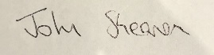
Secretary to the Board of Management

